**DAILY ONLINE ACTIVITIES SUMMARY**

|  |  |  |  |  |  |  |  |  |
| --- | --- | --- | --- | --- | --- | --- | --- | --- |
| **Date:** | **18-06-2020** | | | | | **Name:** | **Preethi** | |
| **Sem & Sec** | **6th - B** | | | | | **USN:** | **4AL17CS065** | |
| **Online Test Summary** | | | | | | | | |
| **Subject** | | **Programming in C** | | | | | | |
| **Max. Marks** | | **-** | | **Score** | | | **-** | |
| **Certification Course Summary** | | | | | | | | |
| **Course** | Workshop on “Applications of Python Programming in DA and ML” | | | | | | | |
| **Certificate Provider** | | | **-** | | **Duration** | | | **-** |
| **Coding Challenges** | | | | | | | | |
| **Problem Statement:1 Java and 1 C program** | | | | | | | | |
| **Status: executed** | | | | | | | | |
| **Uploaded the report in GitHub** | | | | | **Yes** | | | |
| **If yes Repository name** | | | | | <https://github.com/PreethiNayak/Daily-Status/tree/master/18June2020> | | | |
| **Uploaded the report in slack** | | | | | **Yes** | | | |

Online Test Details: (Attach the snapshot and briefly write the report for the same)

Programming in C

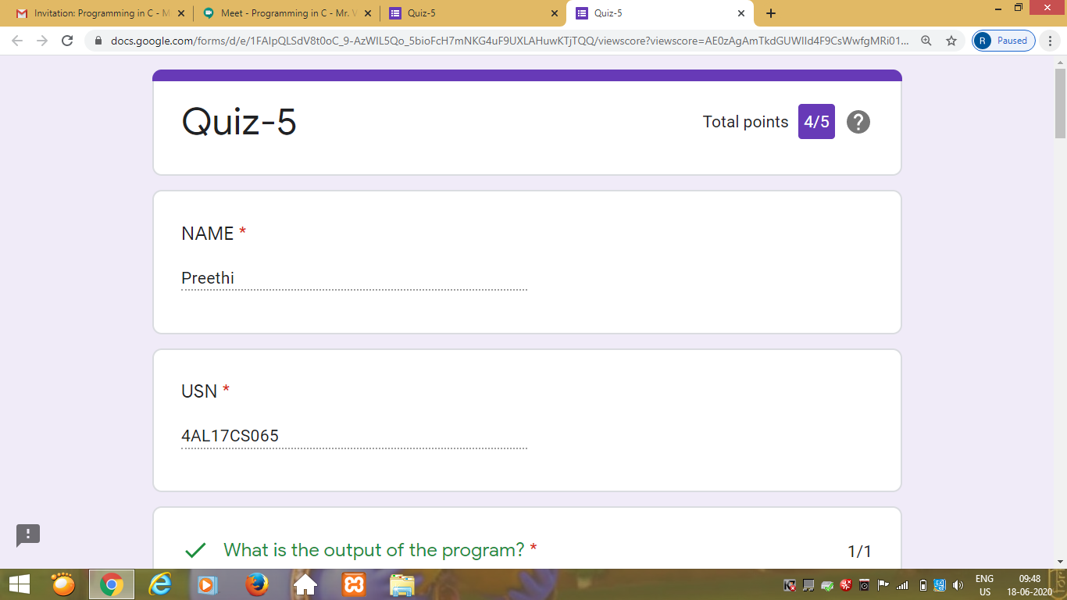

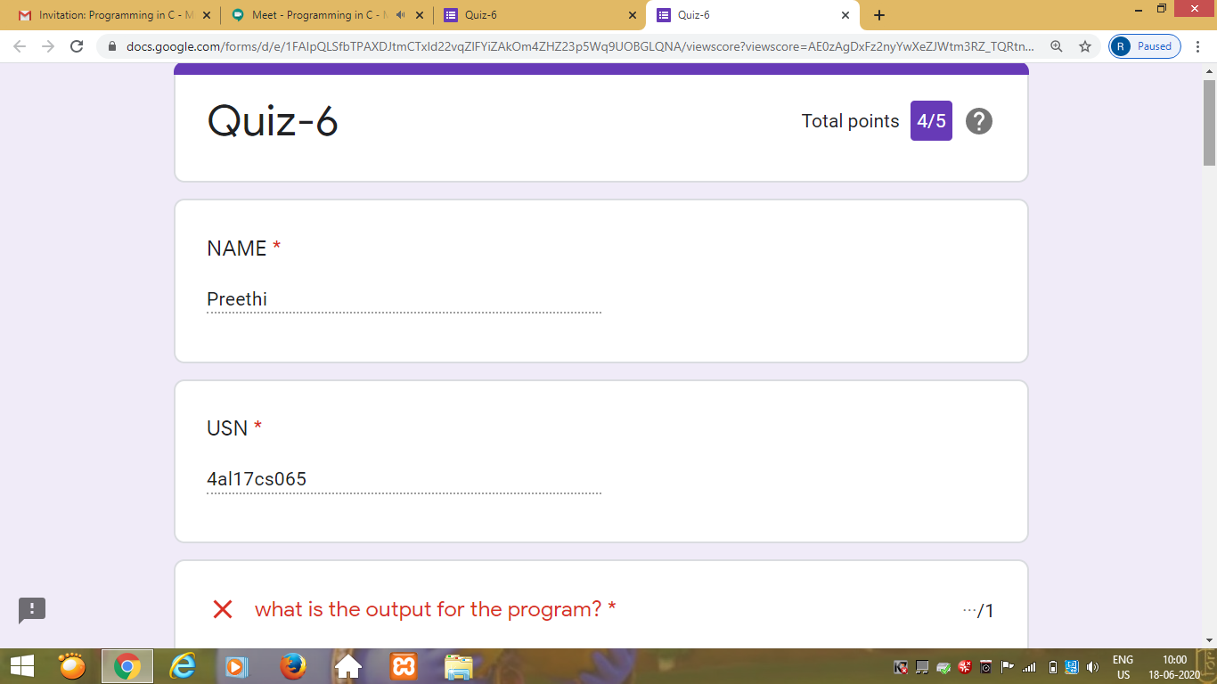

Workshop Details: (Attach the snapshot and briefly write the report for the same)

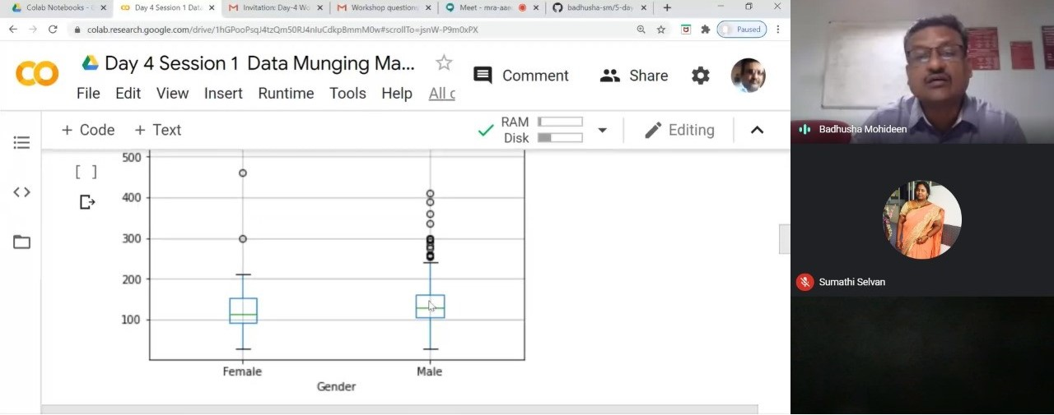

Coding Challenges Details: (Attach the snapshot and briefly write the report for the same)

Program 1

This is output of java program to check if a binary tree is binary search tree or not.

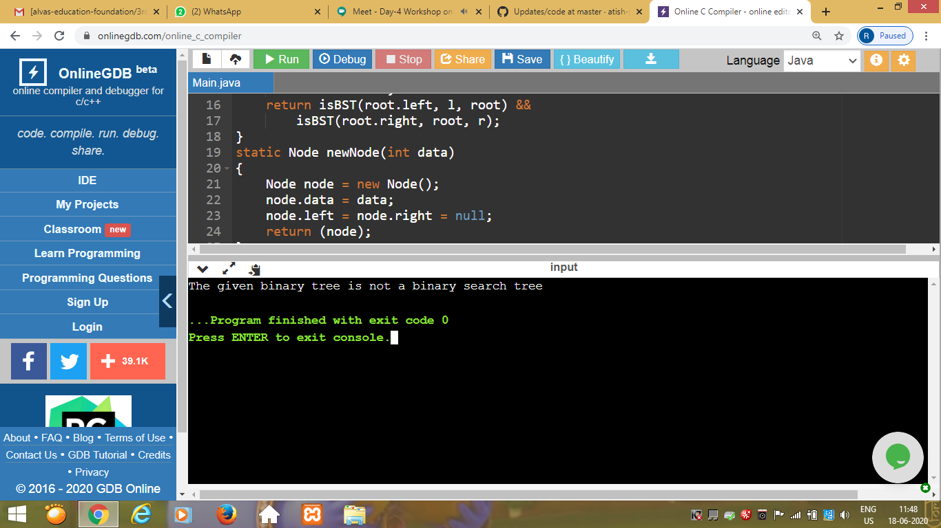

Program 2

This is the output of C program to to generate first N Magic Numbers.

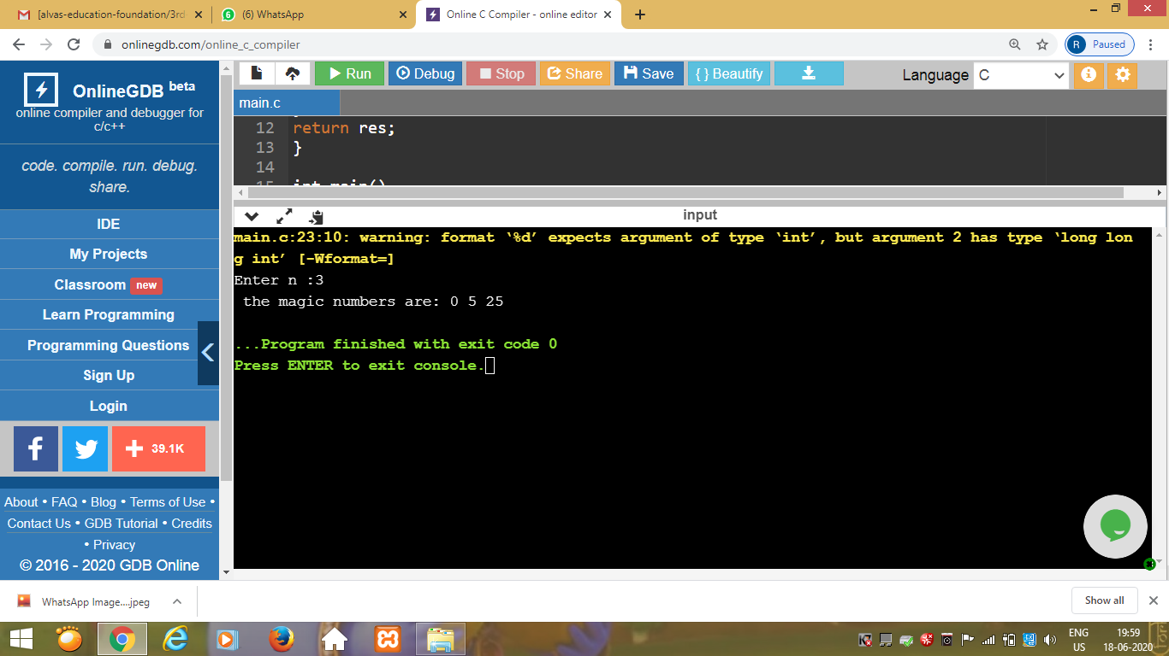

### Workshop on “Applications of Python Programming in DA and ML”

Today’s exercise uploaded in :- <https://github.com/PreethiNayak/Applications-of-Python-Programming-in-DA-ML->